Events and auctions are a popular fundraising combination and can raise significant funds for your organization. Below are some suggestions to consider when planning, promoting, and conducting your event using DonorView. Please note this outline is intended as a guide, not specific requirements. There is a checklist included on the last two pages of this document.
- Planning Stage
- Defining goals for event
- Establish goals for the event including:
  - Ticket sales
  - Sponsorships
  - Auction revenue
  - Expenses
- Defining your goals will help you to:
  - Identify where you should focus your resources
  - Finalize your budget
  - Establish targets for the number of invites and sponsorship requests based on projected response rates
    - If past response rates were around 25% and you have a goal of 100 guests, you’ll need to send out at least 400 invitations to reach your ticket goal.
    - From DonorView, you can create reports to identify the best prospects for your invitations based on geographical location, historical giving, and past event attendance.
- Organize a committee
- A committee of volunteers to help plan and host the event can help alleviate the staff time
- Ensure you have roles and responsibilities outlined for each committee member
- Creating a theme
- Themes make it easier for designing promotional material and advertising.
- A unique theme can make the event more enticing and attract new participants.
- Determining scope and schedule
- Set boundaries for the scope of your event to keep the team focused and help you stay on task.
- Be sure to establish a schedule with activities listed with due dates and who is responsible.
- Incorporate goal tracking and regular meetings to ensure progress is on track.
- Soliciting, collecting and coordinating auction items
- Ensure you know what the rules are for collecting sales tax and rules for gaming, raffles, and auctions in your state.
  - Laws and requirements vary widely from state to state.
  - Sales tax can be automatically determined by the software and overridden if necessary.
  - To learn more about sales tax options in the software in this article: https://support.donorview.com/support/solutions/articles/9000215421-auction-item-sales-tax
- Based on your goals, determine how many action items you need to solicit and secure.
- A good rule of thumb for the number of auction items is to multiply the number of guests by 15 – 25%.
  - For example, for an event with 200 guests a good range of items would be 200 x .15 = 30 to 200 x .25 = 50, so 30 to 50 items.
  - This way you have enough items to generate interest, but not so many that the offerings become overwhelming.
- You might also base the number of items on how many volunteers you have available to collect up the items and check out guests to ensure your guests do not have to wait in a long line for checkout.
- If you have many small, low value items, consider combining them into baskets and packages. This will make the items more unique and appealing and more likely to bring in a higher bid.
- You can use your theme and knowledge of your guests to target the types of items offered. For example, at a golf tournament, you could bundle together a massage, sports shop gift card, and golf lesson as an “Improve Your Game” package.
- As you receive items for your auction, you can enter them as in-kind gifts in DonorView and get a head start on your auction by identifying things like value, initial bid, bid increments, and the description.
- You can see more about recording in-kind donations in this video https://vimeo.com/770827992/663f8edbfb.
- Recording in-kind auction items allows you to acknowledge the gift with the donor right away.

- Promotion & Sales
- Sponsorships & Ticket Levels
- Determine what sponsorship and ticket levels you will be offering for your event.
- For sponsorships, you can set up your sponsorships, link them to event levels, and create a list of tasks using the Sponsorships feature in the Fundraising Module.
  - This will allow you to create tasks and follow-ups to manage the deliverables associated with those sponsorships.
  - You can see more about sponsorships in this video https://vimeo.com/850688116/fdfeda0782 and we’ve just released a new feature to assign follow-ups and you can read more about this in the knowledgebase article here: https://support.donorview.com/support/solutions/articles/9000217093-how-do-i-assign-tasks-for-sponsorship-follow-ups
- Including all your ticket levels and sponsorships on the same event page will make managing attendees much easier since only one event can be shown at a time on the Event Attendance grid.
- If you choose to record your sponsorships manually instead of using the event page, we recommend creating some Offline Level tickets so that you can include sponsor guests along with the rest of the ticket purchases.
  - Offline Level tickets are visible only to DonorView users who are logged into DonorView and using the same browser.
  - You can learn more about creating ticket levels and linking to sponsorships in this video covering event set up: https://vimeo.com/736154790/28f017a613
- Note that there are many options available for tickets including:
  - Early bird or late registration pricing using the “Set Active Level Dates” feature
  - Restricting levels to members only using the “Members Only” feature
  - Allowing just a deposit for a purchase, which is helpful for some larger sponsorships where the registrant may prefer to mail a check. You can learn more about the new deposit feature here: https://support.donorview.com/support/solutions/articles/9000235798-event-level-deposits
- Building the pages
- When you are ready to begin promoting your event and auction, build your pages in DonorView.
- Be sure to connect your auction page to the event page in the Event Settings tab so that bidder numbers can be automatically assigned to registrants and their guests.
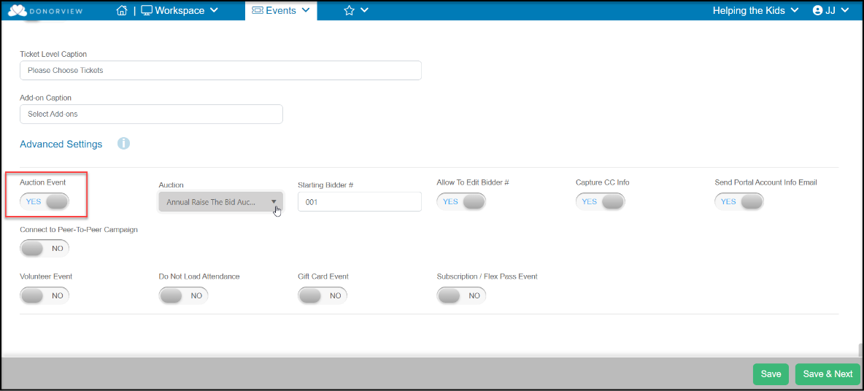

- If you haven’t created your auction page yet, you can choose “Create New” and name your page to activate this feature.
- If you would like to be able to edit bidder numbers from the Event Attendance grid or Auction Bidders grid, toggle “Allow to Edit Bidder #” to “Yes.”
- If you are planning to have an online or text-2-bid auction, you can activate the toggles under “Capture CC Info” and “Send Portal Account Info Email” to give registrants a head-start in creating their accounts.
- If you plan to use the table assignments feature, be sure to turn this on in the Attendee Info tab at the bottom of the page. Activating this does not require that you use it.

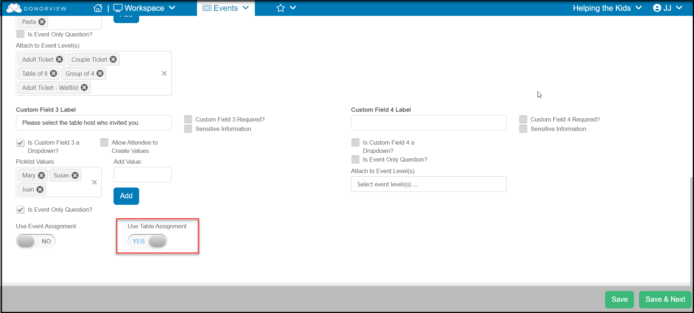
- To see more about setting up an Auction Event, see this video https://vimeo.com/758810143/81a48565e8.
- Develop your marketing strategy
- Determine what methods and channels you’ll be using to market your event
- Ensure your marketing strategy is in line with your budget
- Within DonorView, you can utilize:
  - The email marketing features to send out colorful invitations that include direct links to your pages.
  - The mail merge features including envelopes and letters for paper mail invitations and sponsorship solicitations.
  - The URLs generated from each page to link or embed on your organization’s website and to share on social media.
  - The QR codes that are generated on each page for inclusion in social media, advertising, brochures, posters, and other invitations.
  - Text to URL codes identified for each page can also be promoted and included in marketing.
  - Direct text messaging allows you to send personalized texts to constituents and can even include a brief video message.
- Tracking Sales
- Set up milestones to track progress on your ticket and sponsorships sales. You can see all your event sales in the Events Summary grid, as well as the individual transactions on the Gifts grid.
- Make adjustments to your marketing, promotion, and solicitation strategies as needed.

- Pre- Event
- Event Auto-Reminders
- You can establish a variety of auto-reminders for your event. This video provides an overview of this feature https://vimeo.com/722260141/aa62e84e84
- Auto-reminders can be sent to specific levels, so special messages can be directed to sponsors with a different message sent to single ticket holders.
- Auto-reminders can be linked to the purchase date, before the event date, and after the event date.
- You can also choose any specific date and time to send your message.
- Note that event auto-reminders go to registrants, not all attendees. You can send messages to attendees from the Event Attendance grid.
- If you utilize the portal, your event registrants can also reprint their own tickets and update guest information from the portal.

- Setting up the auction
- Determine if the auction will be:
  - Online/Text-2-Bid
  - Silent (traditional paper bid sheets)
  - Live
  - Hybrid of two or more types
- Determine what add-on items will be for sale at the auction. Add-ons include:
  - Raffle tickets
  - Game tickets
  - Pull tickets
  - Paddle raise donations
  - Fund-a-need donations
  - Call-to-heart donations
- Note that add-on items are not visible on the auction page. They are entered manually into the software via the Auctions Grid.
- You can set up add-on items as “Pay Later” which would allow you to record the items but check them out at the same time as the auction items
- Online/Text-2-Bid Auctions
  - Online/Text-2-Bid auctions require activation of text messaging and the portal.
  - There is no cost to activate the portal only for an auction, however there is a fee associated with setting up a texting number for the DonorView software.
  - If you do not already have text messaging activated, contact support@donorview.com to request activation.
  - To ensure you have adequate time to place practice bids and ensure everything operates smoothly, we recommend requesting texting activation at least 4 weeks prior to the event.
- You can import auction items from your in-kind donation entries as well as manually creating new items. You can learn more about setting up your auction in this video: https://vimeo.com/439042880/7b9664929d.
- Once your auction page is complete (or mostly complete,) you can begin sharing and promoting it with your event attendees.
- For online auctions, you can send an email or text to attendees inviting them to create their portal accounts prior to the event.
- The auction page includes a QR code which can be used to include in event programs or on posters or table tents to invite attendees at the event to register for the online auction.
- Item descriptions and certificates can be printed for all the items in the Auctions grid.
  - Review the item descriptions and certificates prior to the event and make any necessary changes in the auction page’s Set-Up tab.
  - Item description pages include a QR code linked to the item on the auction page so that silent or online bidders can see more details and images for that item using their mobile phones.
  - Silent auction bidders can view the item, but they cannot bid online, they still would need to record their bid on the bid sheet.
- For silent auctions (traditional paper bids)
  - You can print bid sheets from the Auctions grid.
  - Bid sheets can be printed to Word if you need to make any adjustments to the pages.
  - Be sure to print a few extra sheets for each item in case bidding gets really hot on the item and you need extra spaces for bids.
- Credit Card Swipers
- If you will be selling tickets at the door or would like to swipe attendee’s credit cards for faster check out or payment purposes, you can rent special credit card swipers that sync with the DV Connect mobile app.
- Be sure to order your swipers by contacting support@donorview.com at least 3 weeks prior to your event.
- You can learn more about the features of the DV Connect mobile app and how to use it in these videos:
  - Mobile App - iPad: https://vimeo.com/738265241/450ca22c8a
  - New Stripe Swiper - https://vimeo.com/1024079232/ec89adabb3
  - ID Tech Swipers - https://vimeo.com/1024081097/a09b8ceeed
- Testing Your Auction (Online/Text-2-Bid only)
- You can test your auction by creating your own portal account.
- To create your own test portal account, it is recommended that you use a different email than the one you use to sign in to DonorView. This will prevent issues with logging into the backend of the software or the portal.
- Your test account will create a new constituent in the database but can be deleted anytime.
- Note that you will be required to enter a valid credit card to test the bidding, however nothing will be charged.
- You can place bids and practice increasing the bids to see the results in your text messaging as well as the bids in the Auction grid and Bid History grid.
- Bids can be removed anytime using the gavel icon in the Auctions grid and selecting “remove bid.”

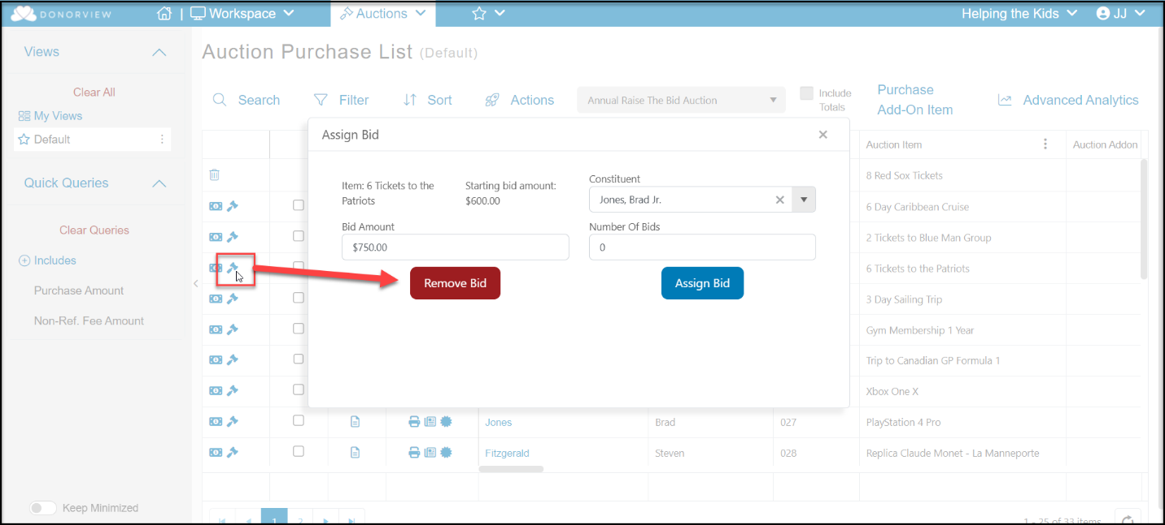

- Managing attendees
- Communications
  - You can find a list of all registrants and attendees in the Event Attendance grid.
  - If a registrant does not know the names of their guests, you will see the registrant’s name as a placeholder in the attendee name column.
  - To update attendee name information or collect answers to attendee questions, can reach out to the registrants.
    - To contact all the registrants, use the Direct Email feature in the Actions menu
    - If you have just a few to contact, you can find their email address on the Event Attendance grid under the column titled E-mail and click on their email to send just one direct email to that constituent.
- Update information on the Event Attendance grid using the edit icon on the right side of the row. You can learn more about the Event Attendance grid in this video: https://vimeo.com/728826049/8dfe9b27d3
- You can resend tickets if necessary to individual registrants or to all registrants from the Events grid.
- Table Assignments
  - Utilizing the table assignment feature is a convenient way to organize the seating chart.
  - You can see the features available for table assignments in this video: https://vimeo.com/741142781/7d79d8b591
- Bidder ID numbers
  - The Event Attendance grid will show the bidder ID numbers for each attendee.
  - Note that bidder ID numbers cannot be shared, and an attendee must be a unique constituent in order to receive a bidder ID number.
  - When creating a new attendee from the Event Attendance grid, an email address will be required.
  - You can also see a list of all bidders in the Auctions module in the Auction Bidders grid.
    - The Auction Bidders grid also allows you to update bidder numbers
    - There is an Actions menu to allow you to email or text bidders as well.
- Attendee Info Questions
  - Any specific questions you included in the event registration page will have the answers shown on the Event Attendance Grid and in the Table Assignments grid.
  - You can also edit this information using the edit icon.
  - This video provides more details about the Attendee Info questions https://vimeo.com/732471168/ab2a288419
- Creating Attendee Packets
  - Organizing and creating attendee packets prior to the event can help expedite the check in process.
  - Suggestions for items to provide the attendees include:
    - A Bidder paddle for live auctions & fundraising during the event
    - Nametags for the attendees
    - A program
    - Auction instructions
    - Table assignments
    - The name and email address used for their constituent record for creating a portal account (if necessary)
    - Wi-fi login (if necessary)
  - You can also mark packets to identify attendees that do not have a credit card on file.
- Volunteers
- Create a schedule and assignments for your volunteers. You can create a volunteer event in DonorView and have volunteers sign up for specific shifts or activities if desired.
- Ensure all staff and volunteers have been given the log in credentials needed to access the mobile app if necessary.
- Provide necessary training for volunteers and staff who will be checking in attendees using the mobile app.
- It is a good idea to assign someone to provide tech support for attendees if you are having an online/text-2-bid auction.
- The tech support person will need to have admin access to DonorView to update portal user information.
- Issues that can come up in an online/text-2-bid auction include:
  - Attendees are unable to access their email on their phone, so you will need to activate their account for them.
  - Attendees not remembering their password, you can reset the password for them.
  - Attendees are locked out of their account due to multiple attempts to login with the wrong password.
  - Spouses attempting to use the same email to create an account.
    - Note that each bidder should have their own account with their unique email address.
    - Two constituents cannot use the same email to create a portal account.
  - You can review some potential login issues and how to correct them in this support article: https://support.donorview.com/support/solutions/articles/9000218757-how-can-i-help-a-donor-who-has-trouble-logging-in-to-the-portal-
- Venue review
- Visit the venue to ensure there is sufficient wi-fi capability to support your devices including laptops, mobile phones, and iPads.
- It’s also a good idea to test cellular service if you are doing an online/text-2-bid auction to ensure attendees can easily place their bids and get notifications.
- If cellular service is poor, be sure to have the wi-fi login and password information prominently displayed for your attendees.
- Create your equipment list based on where you will be set up for your different activities
  - You may need things like extension cords for laptops and printers (if using).
  - Ensure you bring the charging cords and a plug with a USB port to charge the swipers (if using). The swipers can only hold a charge for 4-6 hours.
  - The auction page can feature a widget showing the progress of the fundraising and live bidding updates. You can use a projector to show this to your guests during the event.
  - Having multiple laptops available for the auction check out will help expedite the process.
  - If you plan to print receipts, note that each item will have its own receipt.
    - The system does not provide a single receipt when a bidder wins multiple items.
    - The software will send an automatic thank you email when the payment is processed, so printed receipts may be unnecessary.
- Hosting the Event
- Set-Up
- Equipment
  - Ensure all your swipers are fully charged
  - Test laptops, iPads and iPhones being used for check-in and check-out
- Check In Area
  - Set up welcome packages
  - Set up swipers and sync with iPad/iPhones
  - It is recommended to sync one swiper with just one iPad or iPhone and use them as a unit to prevent sync issues
  - It is recommended to pair a swiper with just one device and keep them together as a unit
- Auction & Other Activities
  - Set up auction items and ensure they are labeled with the auction ID number for quick collection for checkout
  - Provide adequate pens for paper bid sheets
  - For any raffle, games or pulls you are including, set up swipers and iPads/iPhones and/or laptops to record pay-later purchases
- Attendee Check-In
- If using tickets and the scanner feature in the DV Connect app, station volunteers to scan tickets or look up attendees at check-in
- Provide attendees with their welcome packages
- Offer attendees the opportunity to scan their credit cards for faster checkout
- Live Auction and Donations
  - For live auction items, station spotters around the space to watch for bidders and record the bidder number and amount for winning bids.
  - For paddle raises, fund-a-need, or call-to-heart live donation solicitations, stationing multiple spotters around the room.
    - Spotters will write down bidder ID numbers and the amount they are pledging.
    - Suggest spotters focus on specific tables instead of trying to see the entire space.
- Check-out
- It is suggested to end the silent and online/text-2-bid auction early in the evening to allow bid assignments (if necessary) and organization of the items for speedy checkout.
- The Auctions grid Actions menu has a winning bid notification email or text message if you’d like to alert the winners prior to beginning the check-out process.
  - The auto-notification is a standard, non-customizable message.
  - You can also use the “Send Text Message” or “Send Direct Email” to send a customizable message.
- You can invite attendees to checkout and collect their items as soon as the bids are finalized.
- Processing the payments is done in the DonorView software, not the app.
- If you have an exclusively online/text-2-bid auction with no add-ons, you can use the Bid History grid’s Action menu to process all the bids by charging all the credit cards.
- Use the Auctions grid to check out an auction with add-ons or for allowing payments other than credit cards.
- If you have a large event with many auction items to hand out, you may need to have multiple check-out lines to minimize wait time.
- Post Event
- Collecting payments
  - Attendees may leave early before they complete the check-out process. You can produce reports from the Auctions grid to show any amounts due.
  - Attendees with payments due can be contacted with a Direct Email or Text Message.
- Thanking attendees and sponsors
- Your Event Attendance grid will show who actually attended your event.
- You can send a text, direct email or make an email list to let your attendees know your final numbers and thank them for making the event a success.
- Your Event grid will identify your list of sponsors so you can contact them with their post-event thank you message.
- Recording volunteer hours
  - If you did not set up automatic hours via a volunteer event, be sure to record the hours for your volunteers in DonorView.
  - Volunteers can also receive a special thank you for their service.
Auction Event Checklist
Planning Stage
Activity | Responsible | Target  Date |  | Completed Date |  | Notes
Establish goals for the event
Form the event committee
Choose the event theme
Determine the event scope
Create & distribute the schedule
Validate state rules/laws for auctions
Determine target # of auction items
Create auction solicitation list
Other:
Promotion & Sales
Activity | Responsible | Target  Date |  | Completed Date |  | Notes
Determine sponsorship offerings
Determine ticket pricing
Set up sponsorship tasks
Create event page
Develop marketing strategy
Solicit sponsorships
Send invitations
Promote event
Track sales progress
Other:
Pre-Event
Activity | Responsible | Target  Date |  | Completed Date |  | Notes
Set up event auto-reminders
Create auction page
Determine add-ons (if any)
Activate texting (4 weeks prior)
Promote auction (online/text-2-bid)
Print item certificates & descriptions
Print bid sheets (silent only)
Pre-Event (continued)
Activity | Responsible |  | Target  Date |  | Completed Date |  | Notes
Order cc swipers
Download DV Connect app
Test online bidding (if applicable)
Update event attendee information
Finalize table assignments
Verify bidder IDs
Create attendee packets
Set up new users & mobile app
Assign & schedule volunteers
Train volunteers
Verify wi-fi & cell service at venue
Create equipment list
Other:
Hosting The Event
Activity | Responsible |  | Target  Date |  | Completed Date |  | Notes
Charge swipers
Test laptops, iPads & iPhones
Set up check in area
Set up auction items
Record add-ons
Assign bids (as needed)
Notify winners
Organize auction items for pick up
Collect payments
Other:
Post Event
Activity | Responsible |  | Target  Date |  | Completed Date |  | Notes
Collect remaining payments
Send attendee thank you’s
Send sponsor thank you’s
Record volunteer hours
Other:

